1. 클래스들
   1. Shape
   2. circle
   3. Rectangle
   4. Driver

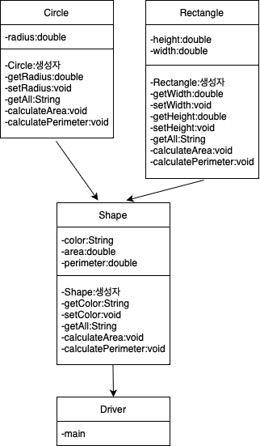

1. 각 클래스 구현
   1. Shape
      1. 변수
         1. color
         2. area
         3. perimeter
      2. 메소드
         1. Shape
         2. getColor
         3. setcolor
         4. getAll
         5. calculateArea
         6. calculatePerimeter
   2. Circle
      1. 변수
         1. radius
      2. 메소드
         1. Circle
         2. getRadius
         3. setRadius
         4. getAll
         5. calculateArea
         6. calculatePerimeter
   3. Rectangle
      1. 변수
         1. height
         2. width
      2. 메소드
         1. Rectangle
         2. getWidth
         3. setWidth
         4. getHeight
         5. setHeight
         6. getAll
         7. calculateArea
         8. calculatePerimeter
   4. Driver
      1. 변수
      2. 메소드
         1. main
            1. 변수

s[]

* + - * 1. 알고리즘

main

Shape s[] = new Shape[3]

클래스 배열 변수 선언

s[0] = new Circle(“빨강”,2.5)

System.out.println(“원: “+s[0].getAll())

s[0].calculateArea()

s[0].calculatePerimeter()

System.out.println(“면적: “+s[0].area)

System.out.println(“둘레: “+s[0].perimeter)

s[1] = new Rectangle(“파랑”,3.0,4.0)

System.out.println(“직사각형: “+s[1].getAll())

s[1].calculateArea()

s[1].calculatePerimeter()

System.out.println(“면적: “+s[1].area)

System.out.println(“둘레: “+s[1].perimeter)

s[2] = new Circle(“초록”,3.0)

System.out.println(“원: “+s[2].getAll())

s[2].calculateArea()

s[2].calculatePerimeter()

System.out.println(“면적: “+s[2].area)

System.out.println(“둘레: “+s[2].perimeter)

end